1-a
Define Artificial Intelligence in your own terms.

Artificial Intelligence (AI) is the art of programming machines to mimic or surpass human intelligence. It's not just about replicating the tasks we do, but also about achieving them with the flexibility, adaptability, and even creativity that define human thought.

1-b

1-c
Consider a Domestic Trading Agent (DTA) which is a software agent supports in purchasing items which are necessary for a family. The members of a family interacts with this agent by specifying the following things to make a purchase

[name of the item to buy, date by when it is needed, price upper limit]

DTA takes a details of list of such items to buy and interacts with many online seller agents. DTA publishes the list of items with the associated details for the seller agents. The seller agents will place bids for each items. DTA analyses the bids and places the order with sellers such that it maximizes its utility. Meeting the expected delivery date, lower costs results in higher utility for DTA.

Write down the PEAS description of the task environment

P = Performance
- Is DTA able to procure all items in the list before date of need?
- How low the price agent could procure the item for?
E = environment
- Client
- Sellers
A = actuators
- Publishing required list to sellers
- Showing chosen list of items to client
S = sensors
- Takes input from client
- Takes item bid price from sellers

1-d
Following is the list of few possible descriptions of a task environment. Write a one line reason why / why not it applies to the given scenario.
- fully observable: Yes
  - Agent is able to see whole environment (client list and sellers)
- Multi-agent:
  - If every family has same/ similar agent, its multi-agent, competing against each other for procuring the items for respective client
  - If only this family has this agent, its not multi-agent
- Stochastic: Yes
  - Agent cant determine the bids of the sellers
- Episodic: Yes
  - Each item is independent of the other

2-a
Comment on completeness, optimality, time & space requirement of the algorithms (column headers in the table) as seen in the table below.

 | IDDFS | UCS | A* | MBA*
Completeness | Yes | Yes | Yes
Optimality | No | Yes | Yes
Time complexity | O(b ** d) | O(b ** (1 + floor(C/e)) | O(b ** Δ)
Space complexity | O(b * d) | O(b ** (1 + floor(C/e)) | O(b ** (ε * d))

2-b
Consider the state space and the associated heuristic given below.

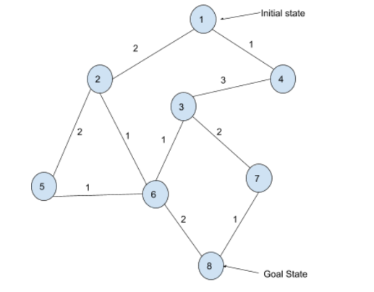

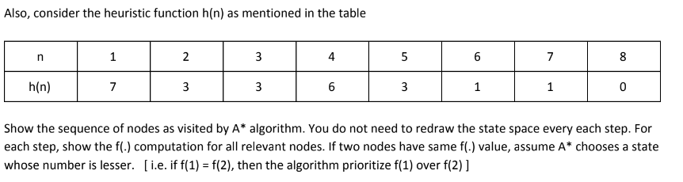

n | h(n) | g(n) | f(n) = h(n) + g(n)
1 | 7 | 0 | 7
2 | 3 | 2 | 5
3 | 3 | 4 | 7
4 | 6 | 1 | 7
5 | 3 | 5 | 8
6 | 1 | 5 | 6
7 | 1 | 6 | 7
8 | 0 | 7 | 7

A* path = 1 > 2 > 6 > 8

3-a
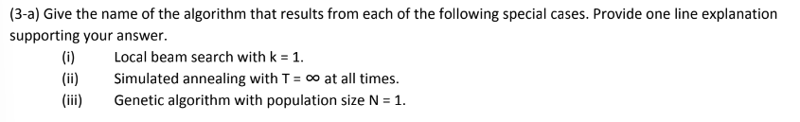

- Hill climbing: Local beam search with k = 1 essentially becomes hill climbing because only one successor state is explored at each step, following the path of steepest ascent.

- Random search: Simulated annealing with T = ∞ essentially becomes random search because with infinite temperature, all states are accepted regardless of their quality, making exploration purely random.

- Elitism: Genetic algorithm with N = 1 reduces to elitism, where only the single individual (chromosome) is kept and copied for the next generation, effectively preserving its traits but lacking any evolution through competition or exploration.

3-b
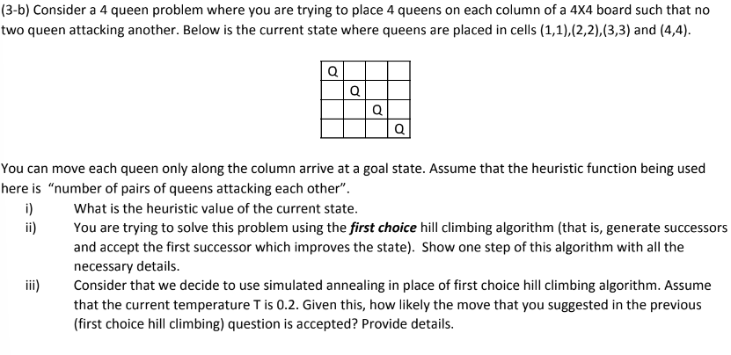
- Current h(n) = 4C2 = 12
as all 4 are attacking other
- Action = moving 1 queen in its column
  - Moving Q1 1 step down
_ _ _ _
Q Q _ _
_ _ Q _
_ _ _ Q

h(n) = 3c2 + 1 = 4
  - Moving Q2 1 step down
Q _ _ _
_ _ _ _
_ Q Q _
_ _ _ Q

h(n) = 4

Etc

4-a

A = 8 = max(2,3,8)
B = 2 = min(8,2,9)
C = 3 = min(6,5,3)
D = 8 = min(9,8)
E = 8 = man(8,1)
F = 2 = max(2,0)
G = 9 = max(9)
H = 6 = max(6)
I = 5 = max(5, 1)
J = 3 = max(3)
K = 9 = max(9)
L = 8 = max(8,4)

4-b

